1. 
2. 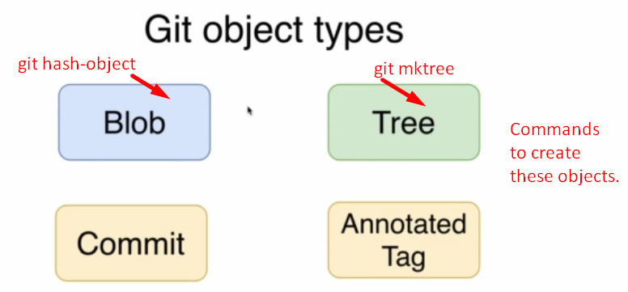
3. 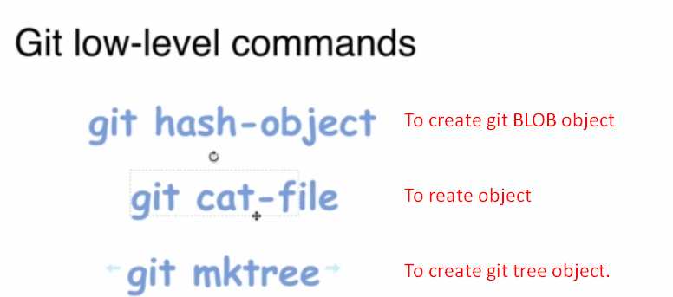
   1. **NOTE**: Why hash in “git hash-object” command? Let’s see in next lec.
4. 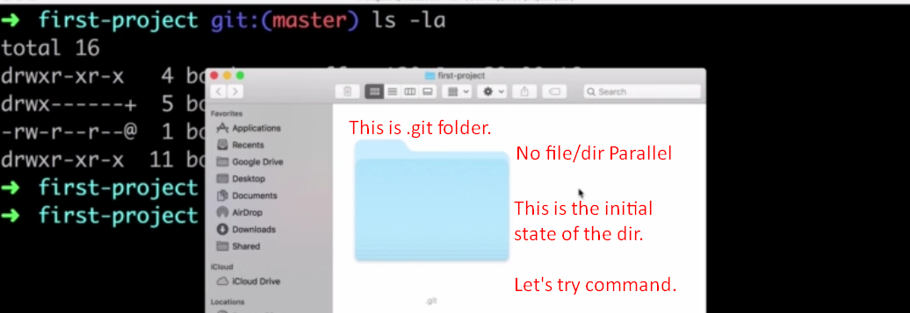
5. 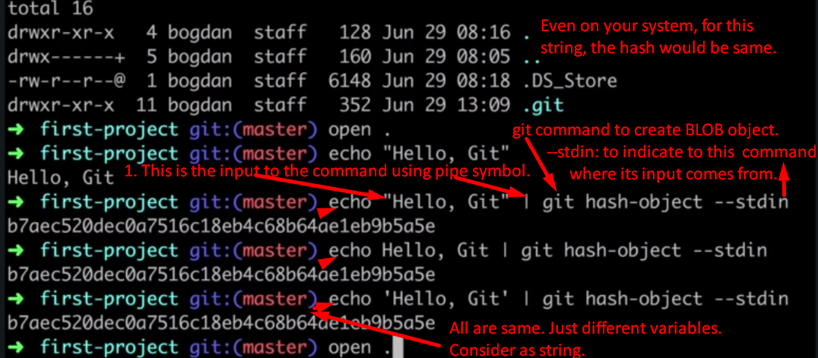
6. 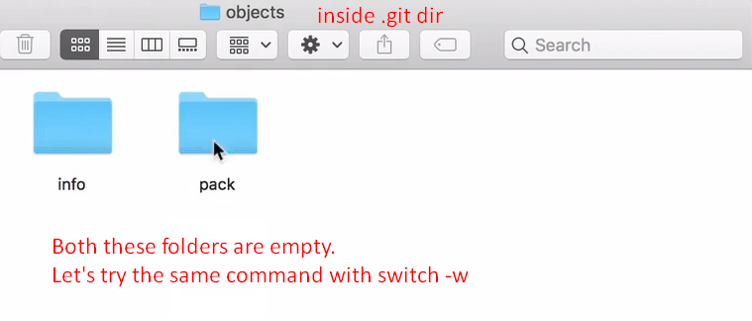
7. 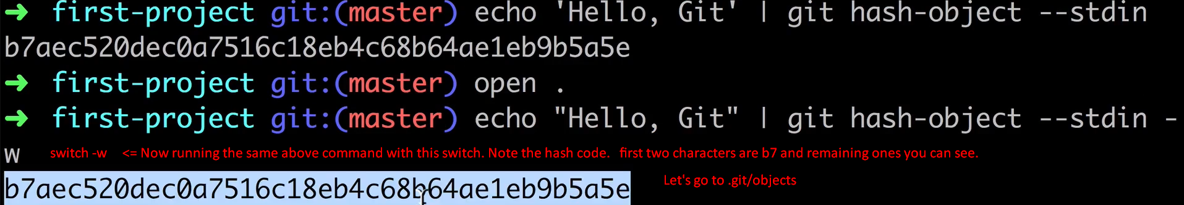
8. 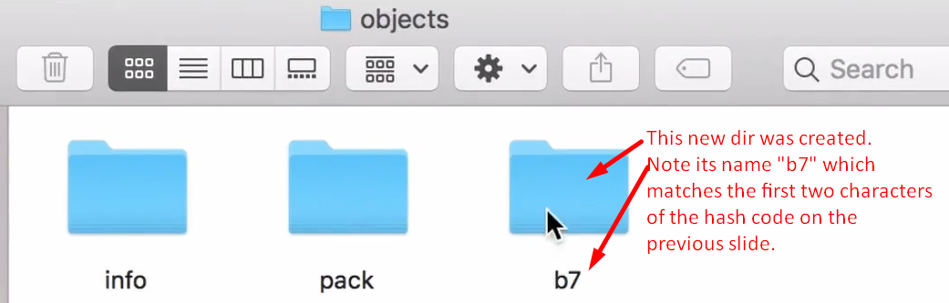
9. 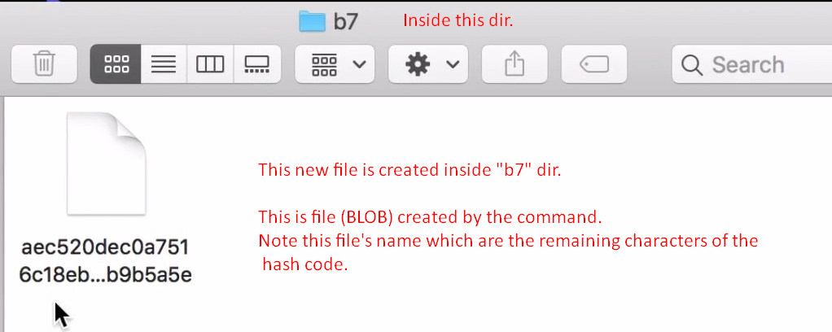
10. 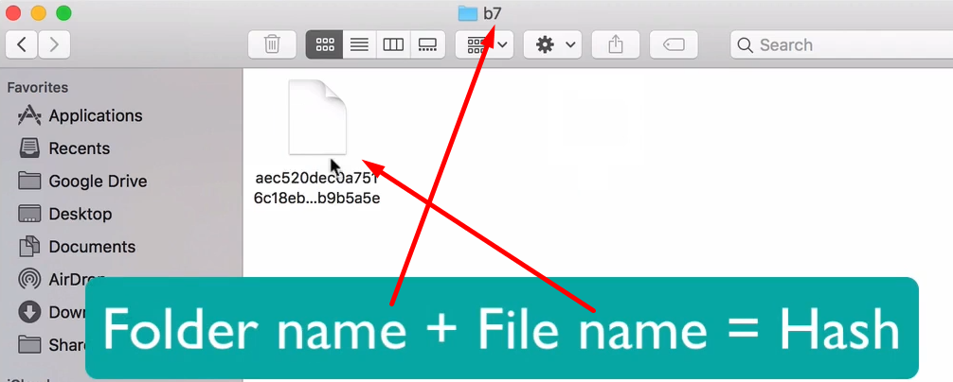
11. 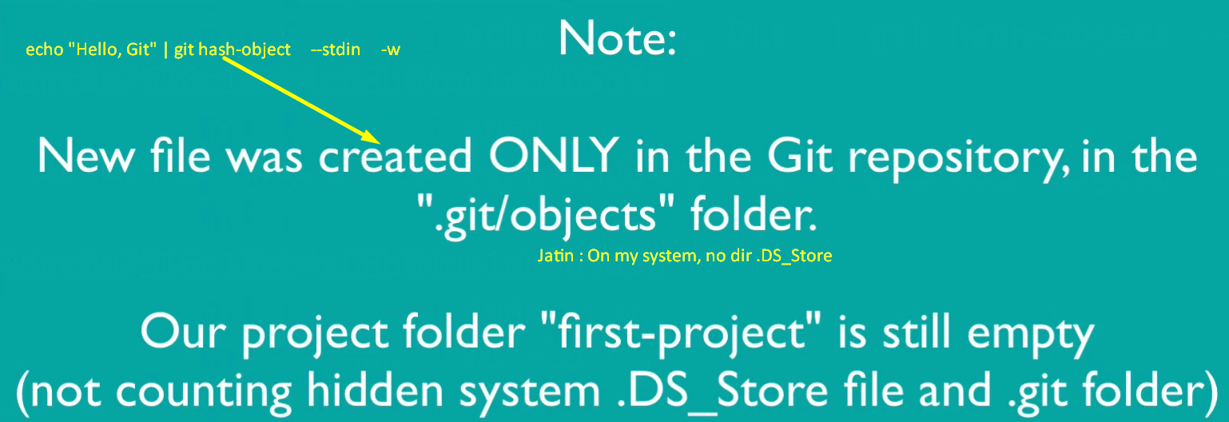
12. **Next Lec**:
    1. What is hash?
    2. How git stores objects in its file system?
    3. how hash is generated?